**Question 1**

Use the Davis Putnam procedure to prove or disprove satisfiability of the formula  
(a V b V c) & (b V not c V not f) & (not b V e)

**Question 2**

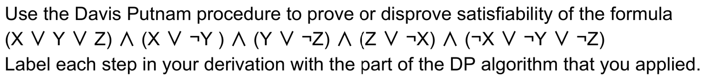

**Question 3**

a. ​​Use the Davis-Putnam algorithm to show if the following set of clauses is satisfiable or not. Label each step with its proper name, and choose the value 0 for the alphabetically lowest letter if you must choose.

(Q v R v ¬T), (Q v ¬R), (P v R v ¬S), T, (¬P v Q v R), (R v ¬U), (Q v ¬S v T), (R v ¬T v U), (¬Q v R), (P v ¬S v ¬T)

b. What is the maximum number of truth assignments that must be tried when executing the Davis-Putnam algorithm, and in which case does that occur?